

**Linux introduction**





# 1. Linux introduction

**What is Linux?**

Linux is an open-source operating system like other operating systems such as Microsoft Windows, Apple Mac OS, iOS, Google android, etc.

An operating system is a software that enables the communication between computer hardware and software. It conveys input to get processed by the processor and brings output to the hardware to display it

The Linux OS was developed by Linus Torvalds in 1991

**Structure Of Linux Operating System-**

An operating system is a collection of software, each designed for a specific function.

Linux OS has following components:

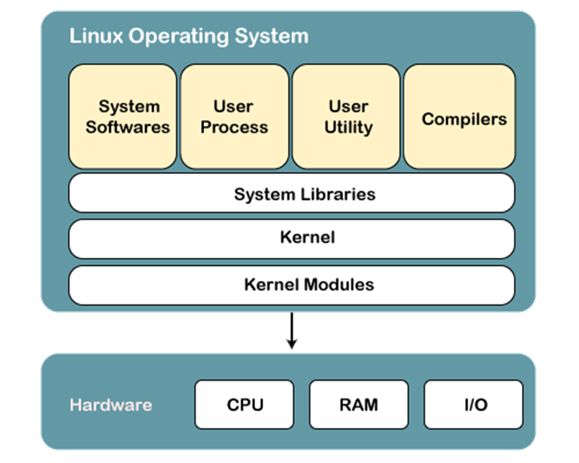

**1) Kernel**

Linux kernel is the core part of the operating system. It establishes communication between devices and software. Moreover, it manages system resources. It has four responsibilities:

1. Device management
2. Memory management
3. Process management
4. Handling system calls

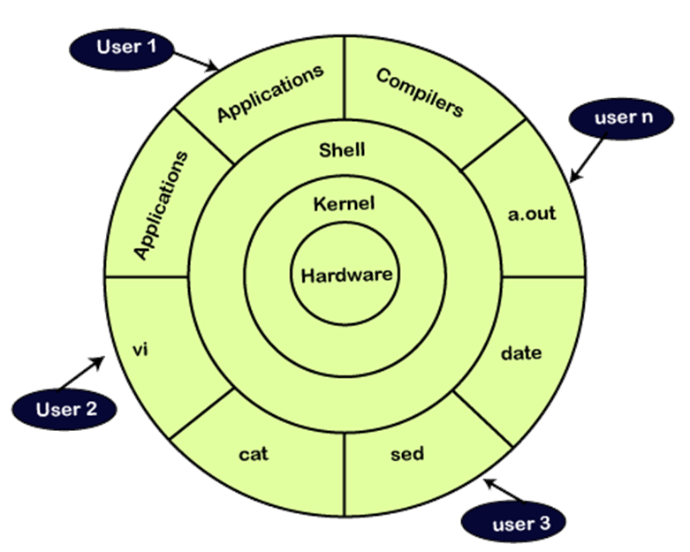

**Why use Linux?**

Linux may be a perfect operating system if you want to get rid of viruses, malware, slowdowns, crashes, costly repairs, and many more. Further, it provides various advantages over other operating systems, and we don’t have to pay for it.

In short, Linux is an operating system that is “**for the people, by the people**.”

## Why is Linux better than other operating systems?

* Open Source
* Security
* Free
* Lightweight
* Stability
* Performance
* Flexibility
* Software Updates
* Graphical User Interface
* Suitable for programmers
* Community Support
* Privacy
* Networking
* Compatibility
* Installation
* Multiple Desktop Support
* Multitasking

**Windows Vs Linux –**

|  |  |  |
| --- | --- | --- |
| Sr No. | Linux | Windows |
| 1 | Free source code i.e open source | Source code is not free or open to all. |
| 2 | Secure | Not secure |
| 3 | Light weight | Not light weight |
| 4 | Linux provides full control to its users on updates. | Windows updates are annoying. The updates will come at any time and take too much time to install. Sometimes, you power on your machine, and updates are automatically getting started. Unfortunately, the user does not have much control over updates. |
| 5 | Multiuser and multitasking is very easy | Limitations to multitasking and multiuser management |
| 6 | Linux is written in assembly language and C. | Windows is written in C++ and assembly language. |
| 7 | Linux has a good support as it has a huge community of user forums and online search. | Windows also provide good support to its user. It provides free as well as paid support. It has an easily accessible online forum. |

**Linux Set Environment Variable–**

Some standard environment variables are as follows:

1. **PATH-**

This variable contains a list of directories in which our system looks for files. It separates directories by a (:) colon.

* **USER-**

This variable holds the username.

* **HOME-**

This variable holds the default path to the user’s home directory.

* **EDITOR-**

This variable contains the path to the specified editor.

* **UID**

This variable contains the path to the user’s unique id.

* **TERM**

This variable contains the path to the default terminal emulator.

* **SHELL**

This variable contains the path to the default shell that is being used by the user.

* **ENV**

This variable displays all the environment variable.

**How to set Environment Variable in Linux?**

export NAME=VALUE

export new_variable=10

echo $new_variable